# CAT18 Script

# User Guide

Version No: 11.0

# Prepared by: Nikki Bromwich

# Date: 13 March 2012

Table of Contents

Purpose of the Document 3

Overview 3

Accessing the CAT18 Script 3

Navigation within the Script 4

Names and Flights TAB 4

Names Section 5

Flights Section 7

Fare Quote Modifiers 8

Confirm TAB 11

PNR 13

# Purpose of the Document

This document is the User Guide for the CAT18 Script V11.0. It describes in detail the steps involved to use the script. All examples in the guide are for illustrative purposes only.

# Overview

The CAT18 script was developed to meet a specific Cathay Pacific (CX), Dragon Airlines (KA) requirement in Hong Kong. It provides a simple-to-use graphical user interface (GUI) and is accessed through an icon on the viewpoint custom toolbar from either Focalpoint or Viewpoint.

The script automates the quoting process and then captures data from the “Note” section of the endorsement field - CAT18 and populates the data into the PNR as unassociated itinerary remarks.

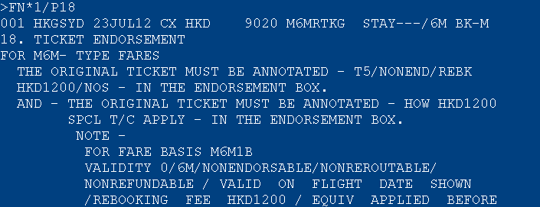



# Accessing the CAT18 Script

|  |  |  |
| --- | --- | --- |
| An active PNR must be open on your screen before you access the script. The CAT18 script will use the names and flights from this PNR when creating the fare.   * Retrieve PNR * Click on the CAT18 Icon from the toolbar     The Script is made up of 2 TABs within the one screen.   * **Names & Flights Screen** - allows you to select the passengers / segments and modifiers for the quote * **Confirm Screen** - allows you to accept or cancel quote     You can exit the script at any time by clicking on the red “X” in the top right hand corner of the application. Navigation within the Script You can either TAB through the screen or use your mouse to click on the options. The Confirm screen (TAB) has a **Back** button, which will take you to the previous screen if required.     Names and Flights TAB This screen is divided into 2 sections, and both the Names and Flights sections must be completed before you can continue. To move to the confirm TAB you need to click “Get Fare Quote”.     **Names Section**  This section is used to update passenger information if required. Any box with a tick can be selected or deselected by clicking on the tick box, depending on your requirements. Once you have made your selection you would then complete the flight section.  The CAT18 script will automatically select all passengers from your PNR and they will default as Passenger Code ADT unless you have specified a passenger type code PTC in the name field of your PNR.  Eg.      Due to CAT35 logic only passengers with the same “Pax Type” can be quoted by the CAT18 script. If you have different passenger code you would need to run the script twice, one for each passenger type.  Eg, Select the Adults only, then run again for the Child    If you want to re-select all passengers you can use the “Name” tick box, located above the individual name boxes.  If you haven’t specified a PTC (passenger type code) in your PNR you can add a passenger code from the Name section. To do this you would need to specify the passenger and then use the drop down “Passenger Code” menu to select a different PTC.  You can use the scroll bar or your arrow keys to move up/down through the list. When the PTC is highlighted in Blue you can either Click or hit TAB to select the option. The new “Pax Type” will be updated in the name table.    Please note: A shortcut is to type the first letter of the passenger code and the list will start from that letter.  The script will allow you to update the Age field, and for a Labour Fare it allows you to add the geography. To do this follow the same steps as above, and then complete the additional boxes as required. Age box will only allow numeric characters, whereas the 2nd geography box allows alpha characters. Once you TAB out of the field the name box is updated.  Eg. Child with Age Eg. Labour Fare with Geography   **Flights Section** |  |  |

This screen is used to add modifiers to the quote as required. Any box with a tick can be selected or deselected by clicking on the tick box, depending on your requirements. Once you have made your selection you would then click on “**Get Fare Quote**” to continue.

The CAT18 script will automatically select all segments from your PNR and populate those into the flight section.

Eg.

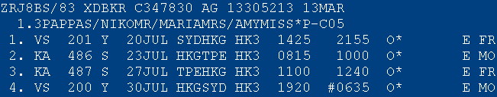

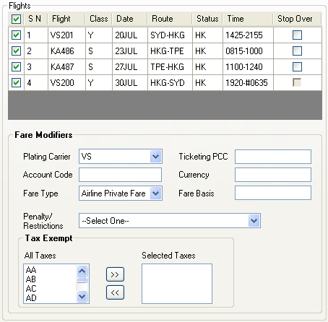



**Segment Select:** To de-select a flight you would click on the tick box of the unwanted segment. Eg. Based on the example below, the script will now quote Segments 2 and 3 only.

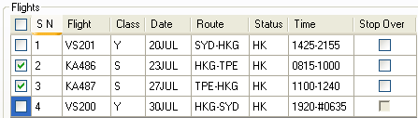

Host example: FQP1*ADT.2*ADT/**S2.3**/CKA/ET:A

If you wish to re-select all flights at once you can use the “Flight” tick box, located above all of the individual tick boxes.

**Stopover:** The stopover box allows you to force in a stopover.

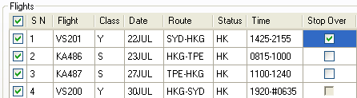

Host example: FQP1*ADT.2*ADT/S1.2.3.4/**O1**/CVS/ET:A

## **Fare Quote Modifiers**

The CAT18 script allows you to select additional modifiers for the quote, if required. When you have finished adding the modifiers for the quote you would click **<<Get Fare Quote>>** to continue.

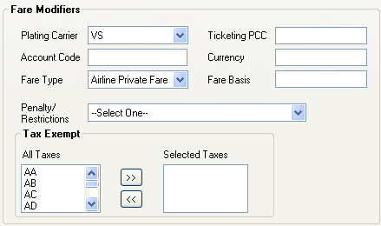



Below are detailed examples of each modifier and the equivalent host entry used when these are selected.

**Plating Carrier –** By default the first outbound carrier will generate into this field. This can be overridden by using the drop down menu to select an alternative carrier already in your itinerary.

 or 

Host example: FQP1*ADT.2*ADT/S1.2.3.4/**CVS**/ET:A

**Account Code** – This field allows you to add an account code.



Host example: FQP1*ADT.2*ADT/S1.2.3.4/**-TEST/**CVS**/**ET:A

**Ticketing PCC** – This field allows you to add a ticketing Pseudo City Code.



Host example: FQP1*ADT.2*ADT/S1.2.3.4/CVS/**TAXD8**/ET:A

**Currency** – This field allows you to add an alternative currency for the quote.



Host example: FQP1*ADT.2*ADT /S1.2.3.4/CVS**::AUD**/ET:A

**Fare Type** – This field is accessed via a drop down menu, and it allows you to select from Published, Airline Private or Agency Private Fares. By script will default to “Airline Private Fares”.

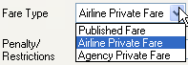

Host example: FQP1*ADT.2*ADT/S1.2.3.4/CVS/ET**:N**

Host example: FQP1*ADT.2*ADT/S1.2.3.4/CVS/ET**:A**

Host example: FQP1*ADT.2*ADT/S1.2.3.4/CVS/ET**:G**

**Fare Basis** – This field allows you to add a fare basis to the quote. The private fare modifier :P will always be attached if this modifier is used, and this can not be changed.

 or 

Host example: FQP1*ADT.2*ADT/**S1@Y.2@Y.3@Y.4@Y**/CVS/ET:P

Host example: FQP1*ADT.2*ADT/**S1@Y.2@YRT.3@YRT.4@Y**/CVS/ET:P

**Penalty / Restrictions** – This field is accessed via a drop down menu, and it allows you to apply a penalty or restriction modifier to the quote.

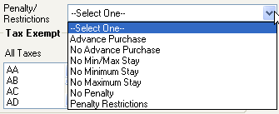

Host example: FQP1*ADT.2*ADT/S1.2.3.4**:AP**/CVS/ET:A

Host example: FQP1*ADT.2*ADT/S1.2.3.4**:NR**/CVS/ET:A

Host example: FQP1*ADT.2*ADT/S1.2.3.4**:MM**/CVS/ET:A

Host example: FQP1*ADT.2*ADT/S1.2.3.4**:NM**/CVS/ET:A

Host example: FQP1*ADT.2*ADT/S1.2.3.4**:PE00**/CVS/ET:A

If you choose Penalty Restrictions, you will need to complete the % text box.



Host example: FQP1*ADT.2*ADT/S1.2.3.4**:PE10**/CVS/ET:A:

**Exempt Taxes**: This field allows you to exempt taxes from the quote. Firstly you need to select the tax you wish to exempt and then click on the arrow to move it to the exempt column. The same process is used to remove the tax.

After clicking in the tax box you can start typing the tax code and the box will automatically move to the codes starting with that letter.

Add: 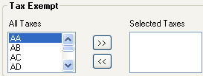 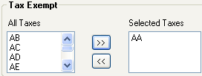

Remove: 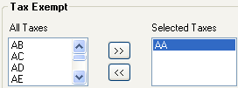 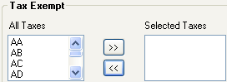

Host example: FQP1*ADT.2*ADT /S1.2.3.4/**TE-AA**/CVS/ET:A

# Confirm TAB

This TAB displays the endorsement text captured from the CAT18 “Note” section of the quoted fare. Once you have added the commission and form of payment details you click on “**Confirm”** to continue.

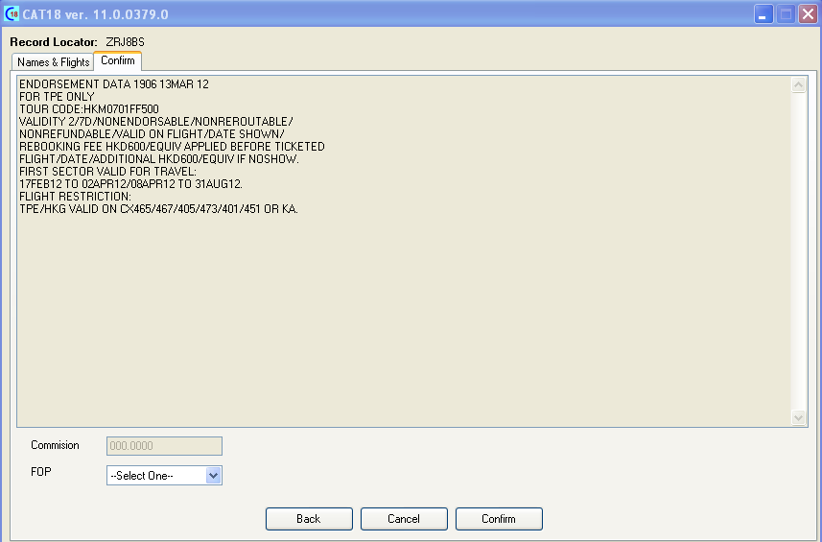

**Commission –** This field will reflect the commission level filed in the fare. If the commission has not been filed then the agent can add the commission level manually before confirming the fare.



**FOP –** This is a mandatory field which allows you to choose the form of payment from a dropdown menu for your filed fare.

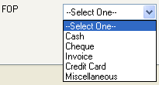

An additional text box is provided when you choose Invoice/Miscellaneous or credit card as the form of payment.







There are 3 options at the bottom of this page: Back / Cancel and Confirm.

**Back –** This will reset the script and return you to the Names and Flights TAB to begin again.



**Cancel –** This option will cancel the quote.



A prompt will be returned asking you to confirm the cancellation.

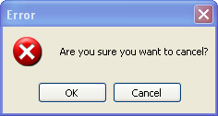

* If you select **Cancel** you will be returned to the Confirm TAB.
* If you select **OK** another prompt will be returned asking if you would like to retry the fare quote.

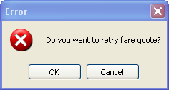

* If you select **Cancel** the script will exit.
* If you select **OK** the script will be reset and you will be returned to the Names and Flights TAB to begin again.

**Confirm –** This option confirms your choice. The script will add the endorsements into the unassociated itinerary remarks of your PNR, and store the filed fare.

The following pop-up box is displayed to confirm the endorsements have been added to the PNR. When you click **OK** the script will close and the PNR will be displayed.

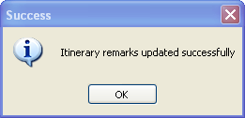

# PNR

You will need to refresh your PNR to see the Filed Fare and the Itinerary remarks.

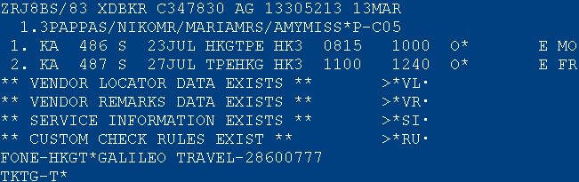

**\*R**

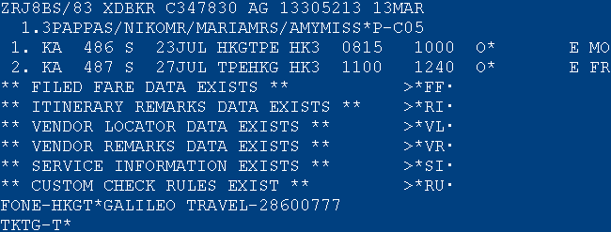

Filed Fare

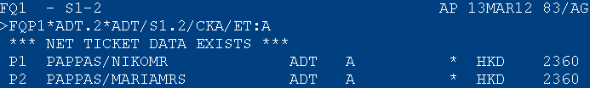

Itinerary Remarks

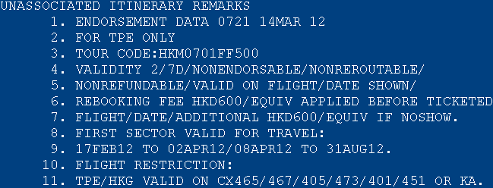

The itinerary remark start with a header which shows “Endorsement Data, time and date” that these were entered into the PNR.